Case Study: LoRA-Based Fine-Tuning for Medical Summary Generation Using Generative AI
Name:R.Mouni(192472283)
Course:Generative AI
Code:CSA6502

Introduction
Large Language Models (LLMs) such as GPT are capable of generating high-quality text for various domains, including healthcare. However, general-purpose LLMs are not specifically trained to produce standardized medical summaries that follow hospital guidelines and medical terminology. Full fine-tuning of these models requires significant computational power, expensive GPUs, large datasets, and considerable time, making it impractical for many healthcare organizations.
Low-Rank Adaptation (LoRA), a Parameter-Efficient Fine-Tuning (PEFT) technique, offers an efficient alternative. Instead of updating all model parameters, LoRA trains only a small number of additional parameters while keeping the original model frozen. This significantly reduces computational cost while maintaining high performance.
This case study explains how a healthcare organization can use LoRA/PEFT to adapt an existing LLM for generating standardized medical summaries.

Problem Statement
A healthcare organization wants to automate the generation of standardized patient medical summaries from electronic health records (EHRs). The summaries should include:
- Patient information
- Diagnosis
- Medical history
- Medications
- Lab test results
- Treatment plan
- Discharge instructions
However, the organization faces several challenges:
- Limited GPU resources
- Small AI infrastructure budget
- Large size of modern LLMs
- Need for secure and accurate medical summaries
- Requirement to preserve the original pretrained model
The organization requires an efficient fine-tuning method that produces accurate results without the high computational cost of full model training.

Objectives
The proposed solution aims to:
- Generate standardized medical summaries automatically.
- Reduce computational and training costs.
- Preserve the pretrained LLM.
- Improve summary accuracy using hospital-specific data.
- Enable quick deployment in healthcare environments.
- Maintain patient data privacy.
- Produce consistent and readable clinical documentation.

Scenario Analysis
Doctors spend a significant amount of time writing discharge summaries and clinical notes. These repetitive documentation tasks reduce the time available for patient care.
Examples of medical information include:
Clinical Data | Example
Patient Name | John Smith
Age | 55 years
Diagnosis | Type 2 Diabetes
Medication | Metformin 500 mg
Lab Result | HbA1c: 8.2%
Treatment | Lifestyle changes + medication
Without AI:
- Doctors manually prepare summaries.
- Documentation takes 10–20 minutes per patient.
- Formatting differs among doctors.
- Human errors may occur.
With LoRA-based fine-tuning:
- The LLM automatically generates structured summaries.
- Doctors only review and approve them.
- Documentation becomes faster and more consistent.

Existing System
Current workflow:
Patient Visit
↓
Doctor Reviews Records
↓
Doctor Writes Summary
↓
Medical Record Stored

Limitations
- Time-consuming
- Inconsistent formatting
- High workload
- Human typing errors
- Delayed documentation

Proposed AI-Based Solution
The proposed solution combines:
- Existing pretrained LLM
- LoRA adapters
- PEFT framework
- Hospital medical dataset
Instead of retraining the complete LLM, only lightweight adapter layers are trained.

Workflow
Patient Records
↓
Data Cleaning
↓
Medical Dataset
↓
LoRA Adapter Training
↓
Fine-Tuned LLM
↓
Medical Summary Generation
↓
Doctor Review
↓
Electronic Health Record (EHR)

Technology Stack
Component | Technology
Base Language Model | GPT / Llama / Mistral
Fine-Tuning Method | LoRA
Framework | PEFT
Programming Language | Python
Deep Learning Framework | PyTorch
Transformers Library | Hugging Face Transformers
Dataset | Hospital EHR Records
Deployment | AWS / Azure / On-Premises

Suitable Model Selection

1. Base LLM (GPT/Llama/Mistral)
A pretrained Large Language Model provides strong language understanding and text generation capabilities.

Justification
The base LLM:
- Understands medical language.
- Generates fluent summaries.
- Supports long clinical notes.
- Requires only lightweight adaptation with LoRA.

2. LoRA (Low-Rank Adaptation)
LoRA introduces small trainable matrices into selected layers of the LLM while freezing the original model parameters.

How LoRA Works
Instead of updating billions of parameters:
- Freeze the pretrained model.
- Add lightweight LoRA adapters.
- Train only adapter parameters.
- Merge adapters during inference (optional).

Benefits
- Very low memory usage
- Faster training
- Minimal GPU requirements
- High-quality results

3. PEFT (Parameter-Efficient Fine-Tuning)
PEFT provides efficient methods such as LoRA for adapting LLMs with minimal parameter updates.

Justification
PEFT:
- Reduces computational cost.
- Preserves the original pretrained model.
- Enables multiple task-specific adapters.
- Makes deployment easier.

Why Use LoRA Instead of Full Fine-Tuning?
Full Fine-Tuning | LoRA Fine-Tuning
Updates all model parameters | Updates only adapter parameters
Requires high-end GPUs | Works on modest GPUs
High memory usage | Low memory usage
Long training time | Faster training
Expensive | Cost-effective
Large storage requirements | Small adapter files
Difficult to maintain multiple versions | Easy to switch adapters

System Architecture
Patient Records (EHR)
│
Data Preprocessing
│
Standardized Medical Dataset
│
Pretrained Large Language Model
│
Freeze Original Parameters
│
Insert LoRA Adapters (PEFT)
│
Train Adapter Parameters Only
│
Fine-Tuned Medical LLM
│
Generate Standardized Summary
│
Doctor Verification
│
Store in Hospital Database

Implementation Approach

Step 1: Data Collection
Collect historical healthcare data:
- Discharge summaries
- Clinical notes
- Diagnosis reports
- Prescription records
- Laboratory reports
- Radiology reports

Step 2: Data Preprocessing
Clean and standardize the data:
- Remove duplicate records
- Correct formatting issues
- Normalize medical abbreviations
- Remove personally identifiable information (PII)
- Convert records into training format

Step 3: Prepare the Base Model
Select a pretrained LLM such as GPT, Llama, or Mistral.
Instead of retraining the entire model:
- Freeze all pretrained weights.
- Load the model into the PEFT framework.

Step 4: Add LoRA Adapters
LoRA adapters are inserted into selected transformer layers.
Only these adapters are trainable.
This dramatically reduces the number of parameters that need updating.

Step 5: Fine-Tuning
Train the model using hospital-specific medical summaries.
Training objective:
Input:
Patient clinical notes
Output:
Standardized medical summary
Only LoRA adapter weights are updated.

Step 6: Evaluation
Evaluate performance using metrics such as:
- ROUGE Score
- BLEU Score
- Medical terminology accuracy
- Clinical completeness
- Doctor review feedback

Step 7: Deployment
Deploy the fine-tuned model into the hospital system.
Workflow:
Doctor uploads patient record
↓
AI generates summary
↓
Doctor reviews
↓
Approved summary stored in HER

IMPLEMENTATION:
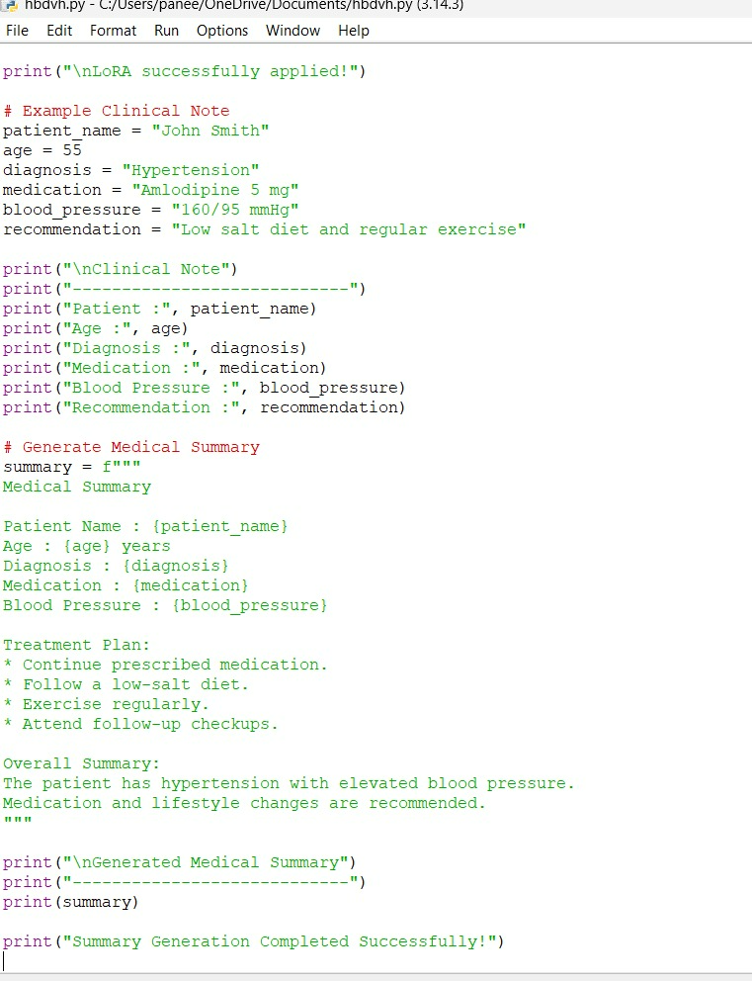

Output:
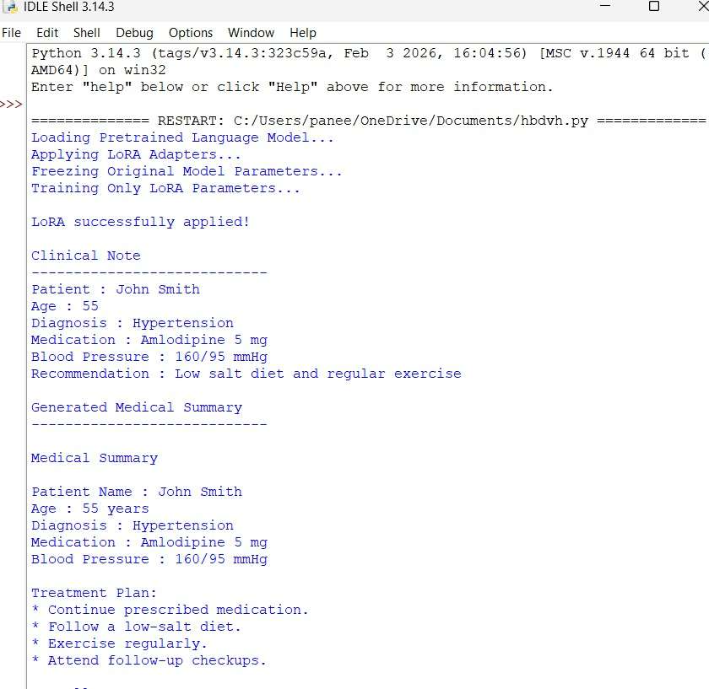

Example Workflow

Input
Patient:
- Age: 60
- Diagnosis: Hypertension
- Medication: Amlodipine
- Blood Pressure: 160/95
- Recommendation: Low-sodium diet and regular exercise

AI-Generated Summary
Medical Summary
"The patient is a 60-year-old individual diagnosed with hypertension. Blood pressure was recorded at 160/95 mmHg. The patient has been prescribed Amlodipine and advised to follow a low-sodium diet, regular exercise, and periodic follow-up visits for blood pressure monitoring."
Doctor reviews and approves the summary.

Advantages of LoRA/PEFT
- Requires significantly fewer trainable parameters.
- Reduces GPU memory consumption.
- Faster training compared to full fine-tuning.
- Lower infrastructure costs.
- Preserves the original pretrained model.
- Supports multiple task-specific adapters.
- Easier to update and maintain.
- Produces high-quality domain-specific summaries.
- Ideal for organizations with limited computational resources.

Expected Outcomes
After implementing LoRA-based fine-tuning, the healthcare organization can expect:
Metric | Before LoRA | After LoRA
Training Cost | High | Low
GPU Requirement | High-end GPUs | Moderate GPUs
Training Time | Several days | Few hours
Memory Usage | Very High | Low
Documentation Time | 10–20 minutes | 1–2 minutes
Summary Consistency | Moderate | High
Model Accuracy | General-purpose | Healthcare-specific
Additional benefits include:
- Improved clinical documentation quality
- Reduced workload for healthcare professionals
- Faster patient discharge process
- Better compliance with standardized reporting

Limitations
Although LoRA/PEFT offers many advantages, there are some limitations:
- Performance depends on the quality of the training dataset.
- Extremely specialized medical tasks may still require more extensive adaptation.
- Human review remains essential for patient safety.
- The model may generate incorrect or incomplete information if provided with poor-quality input.
- Regulatory and privacy requirements (such as HIPAA or local healthcare regulations) must be followed.
- Continuous updates are needed as medical guidelines evolve.

Future Enhancements
The solution can be enhanced by incorporating:
- Multilingual medical summary generation
- Integration with Electronic Health Record (EHR) systems
- Voice-to-text clinical note transcription
- Retrieval-Augmented Generation (RAG) using medical knowledge bases
- Real-time clinical decision support
- Reinforcement Learning from Human Feedback (RLHF) using doctor feedback
- Continuous LoRA adapter updates for new medical standards

Conclusion
LoRA-based fine-tuning using the PEFT framework provides a practical and cost-effective solution for adapting Large Language Models to healthcare applications. By freezing the original pretrained model and training only lightweight adapter layers, healthcare organizations can generate accurate, standardized medical summaries without the high computational cost of full fine-tuning. This approach reduces training time, lowers hardware requirements, preserves the base model, and enables easy deployment of domain-specific AI systems. While human oversight remains essential to ensure clinical accuracy and patient safety, LoRA/PEFT offers an efficient pathway for integrating Generative AI into modern healthcare workflows, improving documentation quality and allowing medical professionals to spend more time on patient care.

